Northumberland Street and Nelson Street Association
Incorporating Abercromby Place

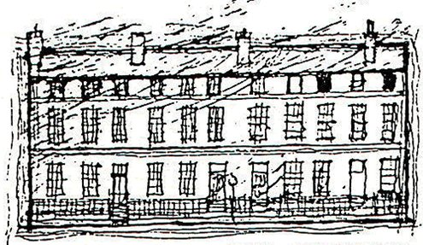

Dear Resident,

The postponed Annual General Meeting of the Association takes place on Sunday, 19th September 2021

The venue will be the Royal Scots Club in Abercromby Place, 29-31 Abercromby Place, Edinburgh.
The meeting will be situated in the Hepburn Suite.

The AGM will commence at 4.00pm until 5.30pm. Our local councillors, and representatives of the police have been invited.

Your Association needs your support in representing your interests in local matters – please come along and support us and join the association, membership form attached.

ANNUAL GENERAL MEETING
4.00pm Sunday 19th September 2021
Hepburn Suite, Royal Scots Club, Abercromby Place

AGENDA
- Apologies
- Minutes of AGM on 21st May 2019
- Election of Office Bearers, Committee Members
- Chair and Treasurer’s Report – to be available
Approval of Statement of Account and subscriptions.
- Police Report
- Council decision on the stopping of Gull Proof Bags.
- Low Emission Zones
- Any Other Business

If you don’t feel able to attend, please submit thoughts or questions via email.

We will post information about the event on our website and Twitter.

E-mail - streetnorthumberland@gmail.com Website: www.nnsa.co.uk Twitter: @thennsa1

